**Lab Task # 01 (Schema Definition):**

**i)**

**Output:**

**ii)**

**Output:**

**iii)**

**Output:**

**Lab Task # 02 (Schema Modification):**

**i)**

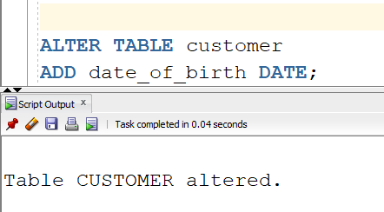

**Output:**

**ii)**

**Output:**

**iii)**

**Output:**

**iv)**

**Lab Task # 03 (Inserting Records into Tables):**

**Output:**

**Lab Task # 04 (Queries):**

**i)**

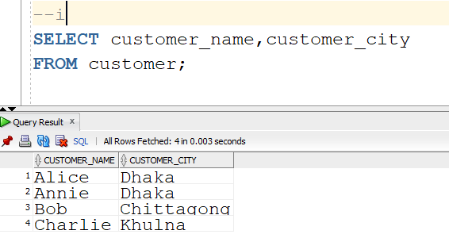

**ii)**

**iii)**

**iv)**

**v)**

**vi)**

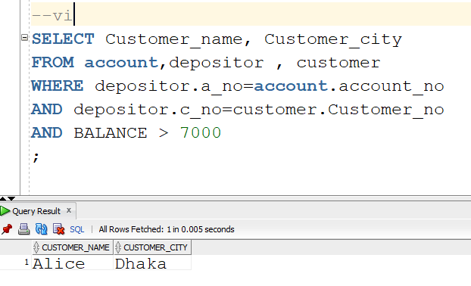

**vii)**

**viii)**

**ix)**

**x)**

